**TASK#1**

Write a C# program that takes a shipping method code (1 for Standard, 2 for Express, 3 for Overnight) and uses a switch case to display the expected delivery time for each method.

**INPUT:**

Console.WriteLine("Select A Shipping Method: ");

Console.WriteLine("1 - Standard");

Console.WriteLine("2 - Express");

Console.WriteLine("3 - Overnight");

Console.WriteLine("Enter The Shipping Method 1, 2 or 3: ");

int shippingmethod = Convert.ToInt32(Console.ReadLine());

switch (shippingmethod)

{

case 1:

Console.WriteLine("Shipping Method: Standard");

Console.WriteLine("Expected Delivery: 14 days");

break;

case 2:

Console.WriteLine("Shipping Method: Express");

Console.WriteLine("Expected Delivery: 7 days");

break;

case 3:

Console.WriteLine("Shipping Method: Overnight");

Console.WriteLine("Expected Delivery: 1-2 days");

break;

default:

Console.WriteLine("Invalid Shipping Method: ");

Console.WriteLine("Please enter Shipping Method 1, 2 or 3");

break;

**OUTPUT:**

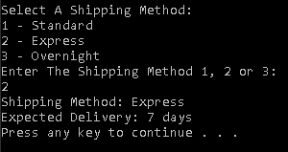

**TASK#2**

Write a C# program that asks the user to select a shape by entering a letter (C for Circle, R for Rectangle, T for Triangle, S for Sphere, P for Pyramid, H for Hexagon), and then use a switch case to calculate the area of shape entered by user.

**INPUT:**

Console.WriteLine("1-Circle");

Console.WriteLine("2-Rectangle");

Console.WriteLine("3-Triangle");

Console.WriteLine("4-Sphere");

Console.WriteLine("5-Pyramid");

Console.WriteLine("6-Hexagon");

Console.WriteLine("Enter The Number For The Particular Shape");

int num = Convert.ToInt32(Console.ReadLine());

switch (num)

{

case 1:

Console.WriteLine("Enter Radius Of Circle: ");

double radius = Convert.ToDouble(Console.ReadLine());

double area = 3.142 * radius * radius;

Console.WriteLine("Area Of Circle Is: " + area);

break;

case 2:

Console.WriteLine("Enter The Length Of Rectangle");

double length = Convert.ToDouble(Console.ReadLine());

Console.WriteLine("Enter The Width Of Rectangle");

double width = Convert.ToDouble(Console.ReadLine());

double area2 = length * width;

Console.WriteLine("Area Of Rectangle Is: " + area2);

break;

case 3:

Console.WriteLine("Enter The Height Of Triangle");

double height = Convert.ToDouble(Console.ReadLine());

Console.WriteLine("Enter The Base Of Triangle");

double base1 = Convert.ToDouble(Console.ReadLine());

double area3 = 0.5 * base1 * height;

Console.WriteLine("Area Of Triangle Is: " + area3);

break;

case 4:

Console.WriteLine("Enter Radius Of Sphere: ");

double radius1 = Convert.ToDouble(Console.ReadLine());

double surfacearea = 4 * 3.142 * radius1;

Console.WriteLine("Surface Area Of Sphere Is: "+ surfacearea);

break;

case 5:

Console.WriteLine("Enter The Side Height Of Pyramid");

double sideheight = Convert.ToDouble(Console.ReadLine());

Console.WriteLine("Enter The Base Of Pyramid");

double base2 = Convert.ToDouble(Console.ReadLine());

Console.WriteLine("Enter The Side Perimeter Of Pyramid");

double perimeter = Convert.ToDouble(Console.ReadLine());

double surfacearea1 = base2 * 0.5 * perimeter * sideheight;

Console.WriteLine("Surface Area Of Pyramid Is: " + surfacearea1);

break;

case 6:

Console.WriteLine("Enter The Side length Of Pyramid");

double sidelength = Convert.ToDouble(Console.ReadLine());

double area4 = (3 * Math.Sqrt(3) * sidelength * sidelength);

Console.WriteLine("Area Of Hexagon Is: " + area4);

break;

default:

Console.WriteLine("Invalid shape");

Console.WriteLine("Please Enter Shape Number 1, 2, 3, 4, 5, || 6");

break;

**OUTPUTS:**

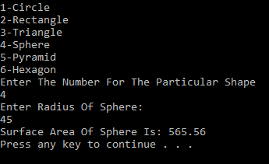

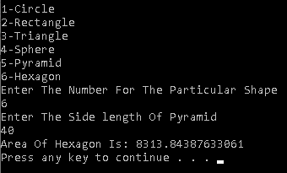

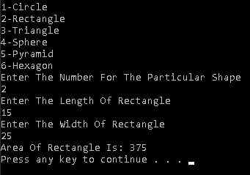

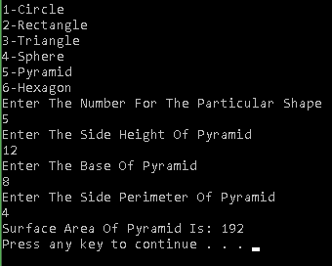

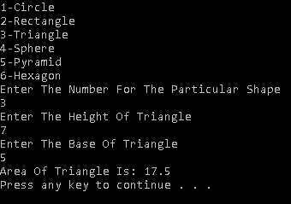

**TASK#3**

Write a C# program that prompts the user to enter a month number (1-12) and uses a switch case to display the number of days in that month, accounting for leap years for February.

**INPUT:**

Console.WriteLine("Enter A Month Number (1-12): ");

int month = Convert.ToInt32(Console.ReadLine());

Console.WriteLine("Is It A Leap Year");

bool isleapyear = Convert.ToBoolean(Console.ReadLine());

switch (month)

{

case 1:

case 3:

case 5:

case 7:

case 8:

case 10:

case 12:

Console.WriteLine("This Month has 31 Days");

break;

case 4:

case 6:

case 9:

case 11:

Console.WriteLine("This Month Has 30 Days");

break;

case 2:

if (isleapyear)

{

Console.WriteLine("This Month Has 29 Days");

}

else

{

Console.WriteLine("This Month Has 28 Days");

}

break;

default:

Console.WriteLine("Invalid Month Number");

break;

}

**OUTPUTS:**

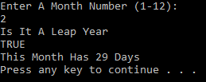

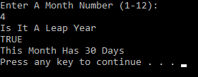

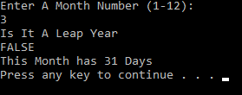

**TASK#4**

Write a C# program that takes two numbers and an operator (+, -, *, /) as input. Use a switch case to perform the corresponding arithmetic operation and display the result

**INPUT:**

Console.WriteLine("Enter Arithmetic Operator +, -, *, /: "); char operation = Convert.ToChar(Console.ReadLine());

Console.WriteLine("Enter Number 1: ");

double num1 = Convert.ToDouble(Console.ReadLine());

Console.WriteLine("Enter Number 2: ");

double num2 = Convert.ToDouble(Console.ReadLine());

double Result = 0;

switch (operation)

{

case '+':

Result = num1 + num2;

break;

case '-':

Result = num1 - num2;

break;

case '*':

Result = num1 * num2;

break;

case '/':

Result = num1 / num2;

break;

default:

Console.WriteLine("Invalid Operator");

break;

}

Console.WriteLine("Result= " + Result);

Console.ReadLine();

**OUTPUTS:**

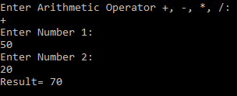 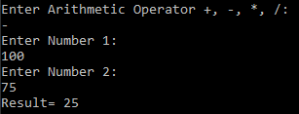

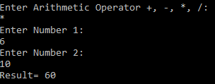 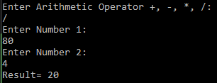

**TASK#5**

**Create a Windows Form application that allows the user to input the number of units consumed,**

**the rate per unit, type of bill to calculate i.e. Domestic, Industrial, or Commercial (using text boxes).**

**Using a switch case, apply the relevant formula and display the total bill based on the selected type.**

**Formulas:**

**⇨ Domestic Bill = (Units * rate) + fixed Charge for Domestic**

**⇨ Industrial Bill = (Units * rate) + fixed Charge for Industrial**

**⇨ Commercial Bill = (Units * rate) + fixed Charge for Commercial**

**Where 500, 1000 and 5000 are fixed charges for Domestic, Industrial & Commercial Bill respectively**

**INPUT:**

double bill = 0;

double units = Convert.ToDouble(txtUnit.Text);

double rate = Convert.ToDouble(txtRate.Text);

string code = txtCode.Text;

switch (code)

{

case "1":

bill = (units * rate) + 500;

string showbill = bill.ToString();

lblResult.Text = "The Total Domestic Bill Is : " + showbill;

break;

case "2":

bill = (units * rate) + 1000;

showbill = bill.ToString();

lblResult.Text = "The Total Industrial Bill Is : " + showbill;

break;

case "3":

bill = (units * rate) + 5000;

showbill = bill.ToString();

lblResult.Text = "The Total Commercial Bill Is : " + showbill;

break;

default:

Console.WriteLine("Invalid Bill");

break;

**OUTPUTS:**

**DOMESTIC BILL:**

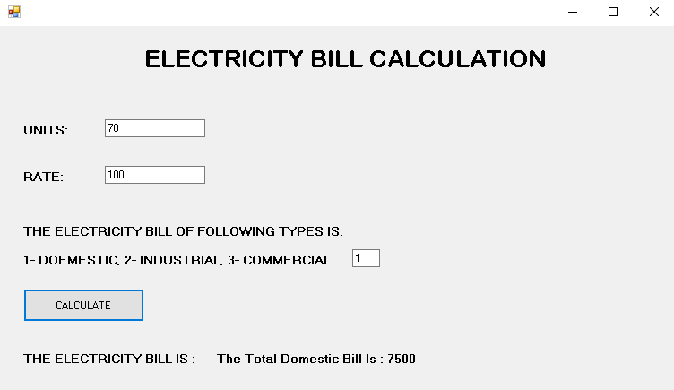

**INDUSTRIAL BILL:**

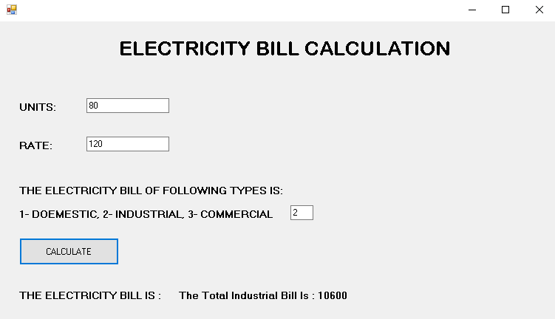

**COMMERCIAL BILL:**

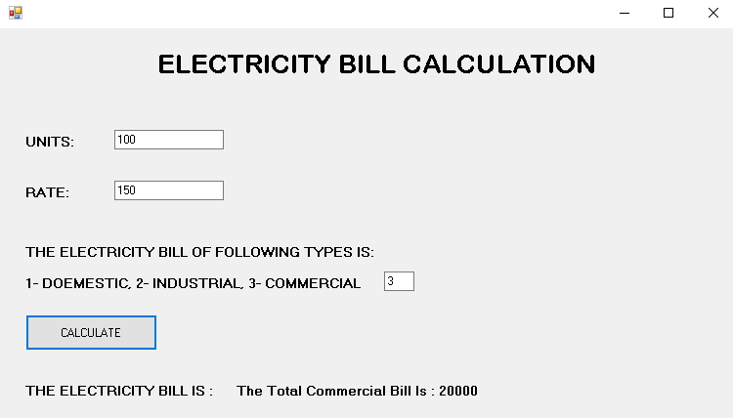

**INVALID BILL:**

